Sand, Soil, Sediment Selection for Beach Nourishment

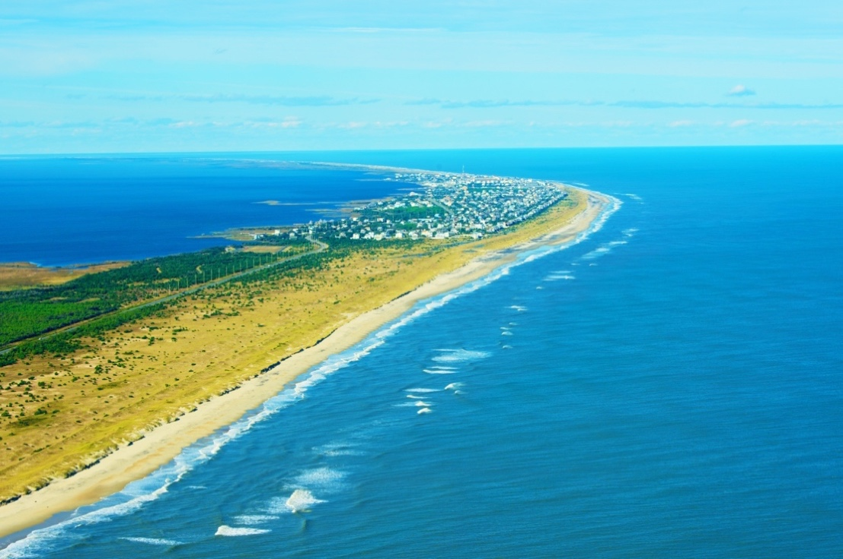

ABSTRACT
Grade Level: 6-8

Duration: 90 minutes

Standards: ESS.EES.2.4, ESS. EES.5.1, ESS.6.2.3

Key Words: erosion, shoreline change, nourishment, community issues
North Carolina’s barrier islands are subject to coastal processes that erode shorelines in some areas, while accreting in others. For places where erosion is occurring, coastal communities are faced with losing their properties, homes, and public beachfront. Municipal governments attempt to combat this loss through engineering projects such as breakwaters, riprap, jetties, and groins, but each of these present their own set of issues in their capacity to widen the beach and advance the shoreline seaward. Where sand comes from for these projects varies, as does the sediment composition and expense.
In a two-year project that began in 2014, the North Carolina Department of Transportation (NCDOT) prepared to dredge an emergency ferry channel located in Rodanthe, NC. In their preparation, the department teamed up with scientists from the Coastal Studies Institute (CSI) to look at the archeological, ecological, and geographical impacts this project would have on a defined research area. Additionally, they also wanted to know how to best utilize the dredge spoil. The spoil, the material that the dredge removes from the sound floor, could offer a viable resource for North Carolina beaches, but what type of sand is found on the sound floor? Are all sands the same? This lesson will explore these questions and more.

OBJECTIVE
Provide an understanding of the role coastal processes and sediment dynamics have on beachfront erosion, the differences in sediment, and the considerations coastal communities must make concerning beach nourishment.
MATERIALS
- Sand sample  - Soil sample  - Beakers  - Sieves | - Stopwatch  - Scale  - Pie dish  - Petri dish

BACKGROUND
Spanning a length of over 300 miles along the Atlantic Ocean coast, North Carolina beaches are subjected to constant reshaping through coastal processes like large storm events, high tides, human interaction, and constant wave action. The dynamics of the coastal processes impacting the shoreline means sediment is constantly in motion either through erosion or accretion. Just one of the methods beach communities use to mitigate the loss of sand are beach nourishment projects. These initiatives bring in sand from suitable locations and deposit the resource in areas of the beach most affected by erosion. Though providing some relief in the short term, these projects can be very costly, time consuming and in some cases ineffective. Despite these issues, many coastal communities in North Carolina use beach nourishment as a method to mitigate erosion.
Locating sand that makes for a good beach is not always easy and is often found in deep marine environments offshore. Sometimes sand can be found in locations closer to the shore, including North Carolina’s estuaries and sounds. The shifting sands of the Outer Banks can be swept away in one area and deposited in another. The inlets of the Outer Banks are locations where, due to changes in water speed, suspended sediment comes out of solution and settles to the sea floor creating shoals. This buildup is hazardous to individuals who use the inlets such as commercial and recreational fisherman, dive boat captains, Coast Guards, marine scientists, and other boaters. The NCDOT is often called in to perform dredging in areas of sediment buildup. To combat the accumulation, the DOT uses a dredge to suck-up sand from the bottom and haul it to a de-watering area.

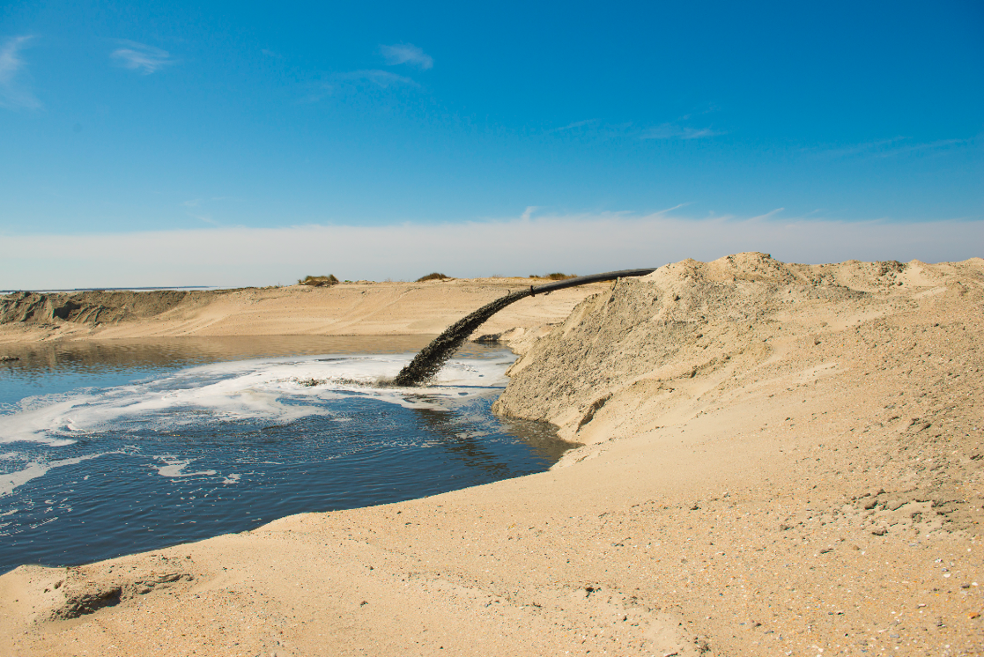
Figure 1. Dredge de-watering site.
This de-watering site is a basin where water is allowed to drain from the dredge spoil leaving the sediment behind. What remains is an amalgamation of sediment including gravel, sand, silt, and clay. The characterization of these different remains relates to their particle size.
Some dredge spoil may be adequate for beach nourishment, but first scientists need to analyze the sediment and compare its attributes with the sediment found at the site in need of nourishment. Aligning the composition of sediment from a source to the area in need of nourishment is important, not only for the success of the project from an engineering standpoint, but also from an ecological one. For example, similar sediment composition is important to the success of sea turtle nesting, egg incubation, and hatching success. Coastal creatures are well adapted to the natural processes of accretion and erosion because these processes naturally occur all the time. However, scientists still have much to learn about the impact beach nourishment has ecologically.
Scientists examine samples from the nourishment site and compare them with samples from the dredge spoil. For this classroom activity, there is a control sample representing the beach nourishment site and there are multiple samples from various sites represented by the samples the students bring in. The control sample is one that the instructor creates ahead of time for the exercise. Through this experiment, students will see how the composition of the different samples vary and if any of the samples provide a viable option for beach nourishment.

For the purpose of this project, the sizes are as follows:

1st sieve – gravel  2nd sieve – fine gravel  3rd sieve – coarse sand | 4th sieve – medium sand  5th sieve – very fine sand  6th sieve – silt and clay

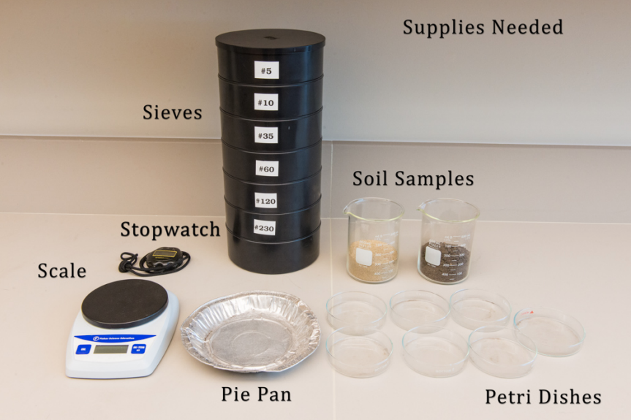

PROCEDURE
The instructor must collect a sand sample, which is weighed, sieved, and catalogued prior to the assignment to act as the target sample. Students are assigned to collect a soil sample, either in class or at home.

Step 1: The instructor assigns students to collect sediment samples. One sample is taken from a vegetation-covered location and a second from a sandy area. Instruct students to remove the vegetation before taking the soil sample. Samples size needs to be at least 1 cup.

Step 2: Back in the classroom, spread the samples out on paper towel and allow sufficient time to dry. This improves the sieving method and can take 24 hours or longer depending upon the saturation of the sample (especially if there’s been a lot of rain recently).

Step 3: Once the samples are dry, have the students crush up the specimens separately, using only their hands, and removing any vegetation as well. Now the samples are ready.

Step 4:

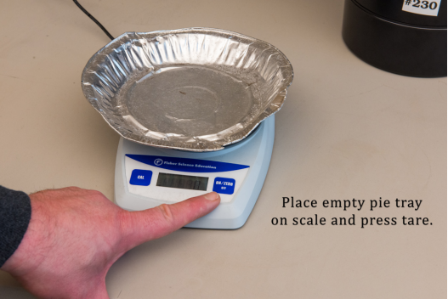

Step 5:

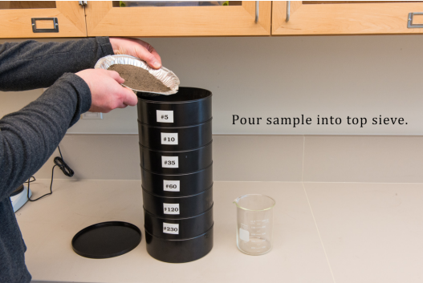

Step 6:

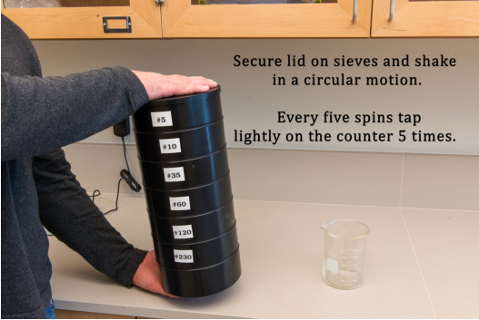

Step 7:

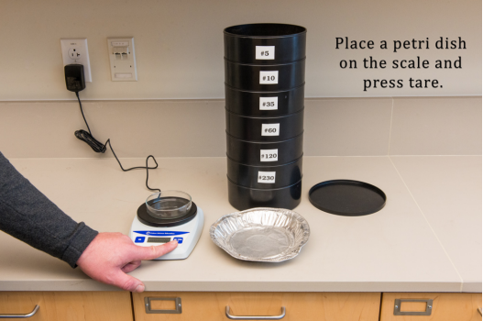

Step 8:

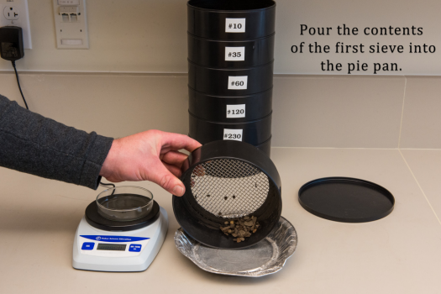

Step 9:

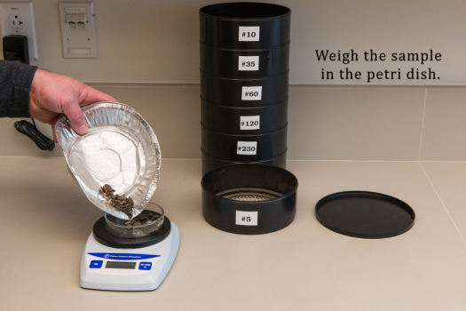

Step 10:

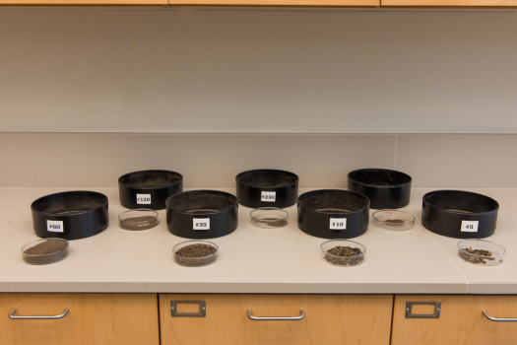

Note: Educational sieve sets start at around $50 online at places like Amazon, but teachers do not have to spend that amount of money to use this lesson plan. More affordable options include colanders, window screening, hardware mesh, panty hose, cheesecloth and other similar materials that work equally well with a little creativity. Additionally, teachers do not have to use actual sediment in this process. A composite of snack foods such as peanuts (gravel), sunflower seeds (sand), Nerds candy (clay) and others work just as easily. And instead of sieves, the students could simply separate the food items by hand and weigh them separately. As long as the methods are conveyed and the composition of the samples are compared to the control sample is emphasized, this activity can be fun and informative.

Data Worksheet

Record the percentages of the control sample provided by your teacher.

Control Sample:
Sieve #1 ___________% - gravel Sieve #4 ___________% - medium sand
Sieve #2 ___________% - fine gravel Sieve #5 ___________% - very fine sand
Sieve #3 ___________% - coarse sand Sieve #6 ___________% - silt and clay

Directions:
- Record the total weight of the sample before sieving.
- After sieving, record the weight of the sediment found in each sieve and record below.
- Take individual weight from each sieve and divide it by the total weight of the sample to get a percentage.

Sediment Sample #1 __________Total weight of sediment sample

____________ Sieve #1 – gravel ____________ % of sample

____________ Sieve #2 – fine gravel ____________ % of sample

____________ Sieve #3 – coarse sand ____________ % of sample

____________ Sieve #4 – medium sand ____________ % of sample

____________ Sieve #5 – very fine sand ____________ % of sample

____________ Sieve #6 – salt and clay ____________ % of sample

Sediment Sample #2 __________Total weight of sediment sample

____________ Sieve #1 – gravel ____________ % of sample

____________ Sieve #2 – fine gravel ____________ % of sample

____________ Sieve #3 – coarse sand ____________ % of sample

____________ Sieve #4 – medium sand ____________ % of sample

____________ Sieve #5 – very fine sand ____________ % of sample

____________ Sieve #6 – salt and clay ____________ % of sample

DISCUSSION

- Which size sediment makes up the highest percentage of sample #1? What percentage is it?

- Which size sediment makes up the highest percentage of sample #2? What percentage is it?

- How do the two samples differ?

- What conclusions can be drawn from these differences?

- Which sample aligns most closely with the control sample?

- Would your sample offer an adequate source for beach nourishment? Explain why or why not.

EXTENTIONS
This topic offers a lot of opportunity for in-class discussion including the role of taxpayers in providing this resource, how climate change and rising sea levels will impact current methods of beach nourishment, and alternatives to beach nourishment projects. There are a number of excellent resources out there that grapple with this issue and could offer alternative talking points.
- The Town of Nags Head, North Carolina provides information on its shoreline management projects and can be found at this site: http://www.nagsheadnc.gov/index.asp?Type=B_BASIC&SEC={F03A935D9758-476A-8732-13B89EBAB548}
- The U.S. Army Corps of Engineers provides an informative publication called the Shore Protection Assessment and it can be accessed here: http://www.asbpa.org/publications/fact_sheets/HowBeachNourishmentWorksPri merASBPA.pdf
- For a documentary on coastal communities and their relationship coastal processes that shape our shores go here: http://shoredupmovie.com/
- The Coastal Processes program at the UNC Coastal Studies Institute home page offers a number of resources that covers this topic as well as others affecting our coastal communities. Visit the program page for information about current research projects conducted at the Institute: http://coastalstudiesinstitute.org/research/coastal-processes/
- For a video on how scientists monitor the shorelines in North Carolina click here: https://www.youtube.com/watch?v=cYxZNG7AxLg

